Task01
#!/bin/bash
echo "Hello whos this?"
read n
echo "Hello,$n"

Task02
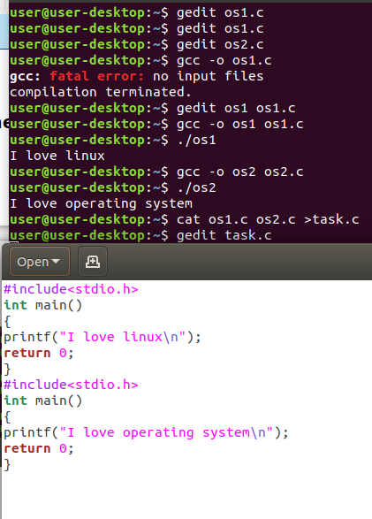

Task 3:

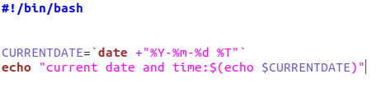

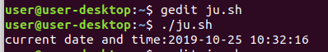

Task04

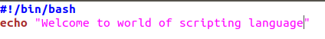
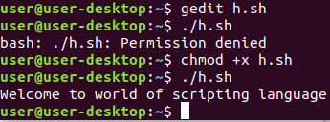

Task05

